Visual AnalysisTommy Umholtz

Art History - Online

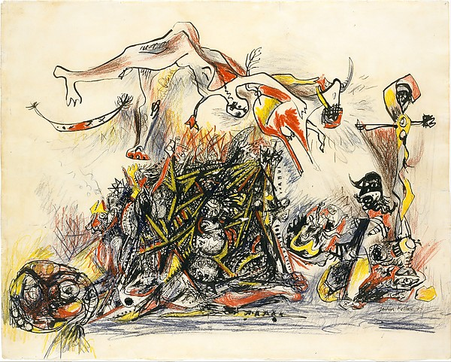

War (52.4 x 66 cm), a drawing produced by Jackson Pollock in 1947 is a piece of abstract impressionist art which relates to the images from World War II. War is a depiction and culmination of images that Jackson produced during World War II. Formal elements that strike me are color with high contrast between adjacent colors and the dead space in the image. I also see the colors being very vivid and saturated. Jackson’s images of abstract impressionism are usually a mix of vibrant colors and contrast. “War” is unique in being a piece that Jackson titled. Line is another formal element that strikes me as those that are displayed are prominent and well defined. Because of Jackson’s painting technique sharp and defined lines are going to appear in his painting, as for this drawing it shows those qualities as well.

Movement is apparent here with what seems to be a combat like explosion and human figures thrown about. Symmetry is no really existent with the entire image being asymmetrical. The focus of the image is on the center slightly to the left with a chaotic mass which then moves to the figures above it as they are thrown in the air. There is also a repetition of shapes and colors through out.

Pollock, J. (1947). War [drawing]. Retrieved from

<http://metmuseum.org/collection/the-collection-online/search/482445?=&imgno=0&tabname=related-objects>

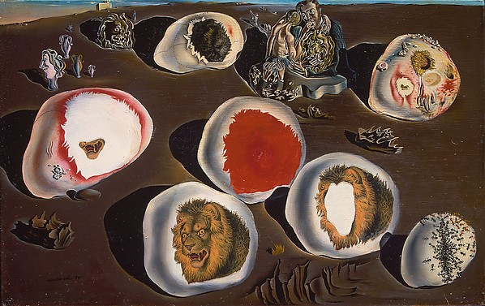

The Accommodations of Desire (22.2 x 34.9 cm) a painting produced by Salvador Dali in 1929 is a piece of Surrealist art which deals with a relationship Dali was having with a married woman. There is a lot of direct symbolism in this image that he relates to his future, from terror represented in the lions figures to deterioration from the group of ants. Interestingly the images of the lion’s heads are not actually painted but a superimposition to the painting being cut out from a children’s book. The formal elements that strike me in this image are also color contrast with high contrast being with the white objects or pebbles and brown sand background and shadows. Defined shapes are prominent with the round objects being framed by solid lines.

The picture is well balanced and somewhat symmetrical through out with a feeling that all the elements are laid out evenly. There is a sense of depth in the image with the objects in the foreground being larger than those going towards the background. At the very top near in the left third section of the image there is even what appears to be a small building, the dimension in this painting is not to scale which adds to its surrealism.

Dali, S. (1929). **The Accommodations of Desire** [painting]. Retrieved from

<http://metmuseum.org/collection/the-collection-online/search/490036>

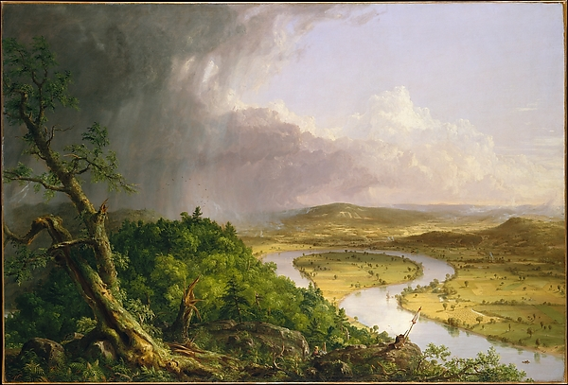

View from Mount Holyoke, Northampton, Massachusetts, after a Thunderstorm (130.8 x 193 cm) also known as The Oxbow is landscape oil on canvas painting completed by Thomas Cole in 1836. This landscape scene is purportedly inspired by trips to Europe Cole had made a few years earlier. In response to criticism received from Capt. Basil Hall of the English Royal Navy about American imagery lacking attention in landscape views Cole produced a painting that embodied an eclectic view of American nature. With in this scene are views of a wooded area in the left foreground, hills and small settlements spanning into the distance and thunderstorm and a sunny sky.

The use of space in this painting is over all open which would be natural for a landscape scene. In the left foreground a tree is painted which takes up almost a third of the canvas while the rest of the image represented by openness going into a distance. The color is not flat but fairly contrast especially with the dark wood area green and thunderstorm to the light and sunny field and right sky view.

Proportion seems mostly to scale as I feel this painting could transpire to a photographic image. Balance feels weighted towards the lower left with heavy close up detail while the top right is an empty sky. Even though the left side of the image has most of the detail I feel I am focused more on the center area where the river loops and and even to the pasture on the right. This feeling might change if I were to view the painting in real life.

Cole, T. (1836). View from Mount Holyoke, Northampton, Massachusetts, after a Thunderstorm [painting].

Retrieved from

[http://metmuseum.org/collection/the-collection-online/search/10497?high=on&rpp=90&pg=1&rndkey=20160118&ft=*&pos=76](http://metmuseum.org/collection/the-collection-online/search/10497?high=on&rpp=90&pg=1&rndkey=20160118&ft=*&pos=76)